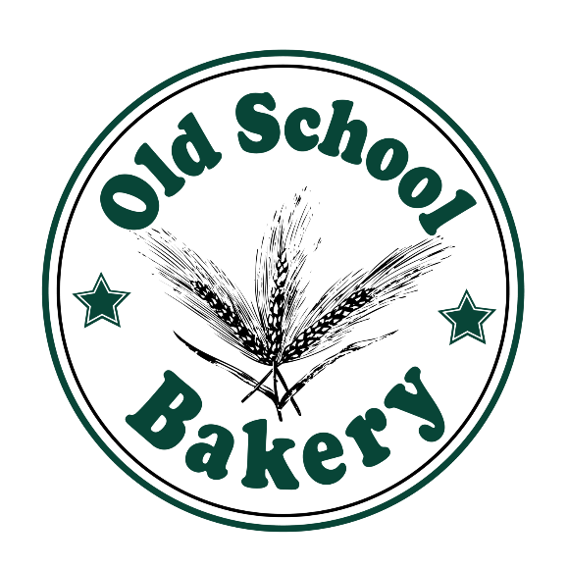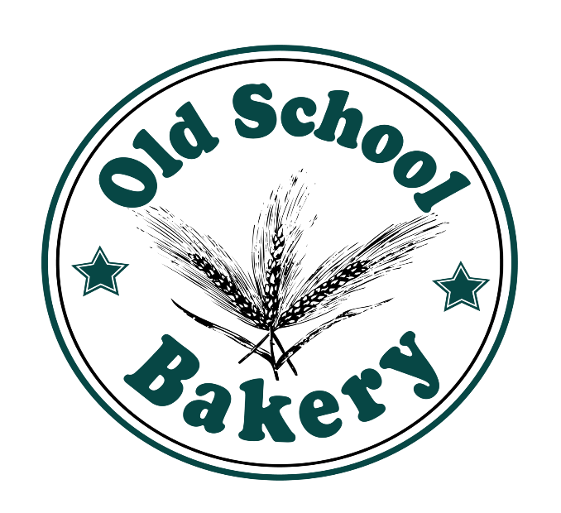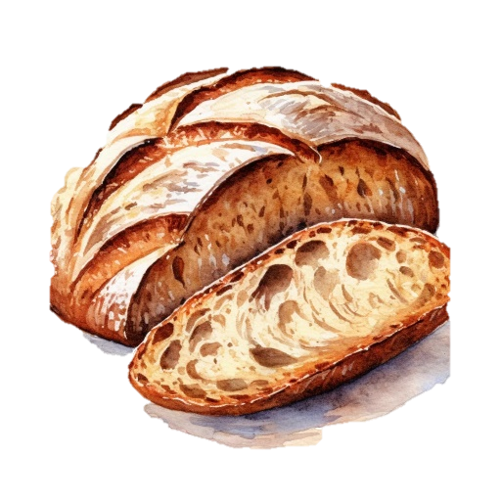

CONTACT US

Email: oldSchoolBakery@plpsd.ca

www.oldSchoolbakery.ca

**WHY CHOOSE US?**

* **We’re affordable**
* **We’re near by**
* **We have quality products**

CAKE

Delicious

Best Cake in Town

Use Promocode uw125x to get a 10% discount!



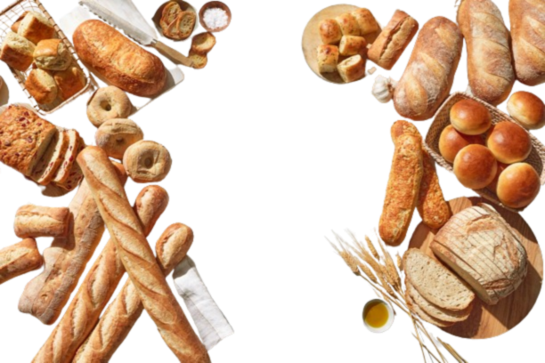

**WHY CHOOSE US?**

* **We’re affordable**
* **We’re near by**
* **We have quality products**

CONTACT US

Email: oldSchoolBakery@plpsd.ca

www.oldSchoolbakery.ca

CAKE

Delicious

Best Cake in Town

Use Promocode uw125x to get a 10% discount!